CHEM 570                                                                                 Name

**Midterm 2**

**November 9, 2017**

**Please make sure your answers are legible; otherwise they will not be graded.**

**One figure can say a thousand words --- use it wisely.**

1. Short answers (30pt)
2. Shown below is a lipid-binding reactive probe. Label three moieties and identify their functions (6pt)



I had meant to say a reactive probe for “lipid-binding proteins” --- I gave everybody full points.

1. List two residues that the probe shown below would target in the proteome (4pt)



Cysteine, Lysine, other nucleophilic residues

1. Many argue that phenotypic screens would lead to more NME: what does this stand for? (2pt)

New molecular entity, enbeded in Lecture 11

1. Stem cells are used to treat leukemia and various immune deficiency diseases. List and describe two potential adverse events that can affect patients (6pt)
2. Teratomas: undifferentiated ES cells can grow into large tumors from pluripotent cells
3. Immunogenicity: rejection of the injected stem cells by the patients’ immune system
4. Describe the benefit of mirror-image phage display (2pt)

Efficiently develops D-peptide that will bind to the L-target. Protein targets in human body are often L. D-peptides binds tightly to the target and are less susceptible to proteolysis.

1. Draw a diagram of how the yeast two-hybrid system detects biomolecular interactions. Make sure you label each component of the system. (6pt)

Lecture 18b-12

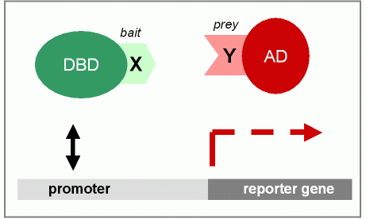

1. List two biomolecular interactions that yeast-hybrid system can detect. (4pt)

Protein-Protein, small-molecule- protein, RNA-protein, small-molecule-RNA etc

2. While advancement in the sciences has improved the survival rate of cancer patients, cancer remains as the second leading cause of death in the United States, killing 600,000 people in 2016.

1. Depending on the cell type, cancers can be categorized into three. List these three and the cell types (3pt)

Carcinoma (epithelial cells), sarcoma (mesoderm cells) and adenocarcinoma (glandular tissue)

1. List two DNA alkylators. (2pt)

Lecture 17-8

1. What is personalized medicine? Define and provide one example of approved personalized therapeutics and its target. (6pt)

ie targeted therapy –only target molecular defects in cancer, see Lecture 17-17

1. When cancer is diagnosed at a late stage, the primary tumor has often metastasized to different tissues and makes the treatment challenging. Describe 6 steps of metastasis (6pt)
2. migration
3. intravasation
4. transport
5. extravasation
6. metastatic colonization
7. angiogenesis

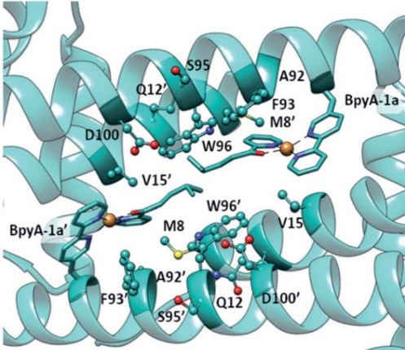

1. Drienovska and others have recently reported a design of an enantioselective artificial metalloenzyme. They manipulated the original catalytic activity of *LmrR* by installing an unnatural metal-binding amino acid. (*Chem. Sci.* **2017**, *8*, 7228-7235)
   1. What is one codon most utilized in unnatural amino acid incorporation? Make sure you write out the nucleotide sequence of the codon and its common name. Why is it used in unnatural amino acid incorporation? (4pt)

UAG, Amber, least used codon in E Coli – removal from E coli would not affect growth

* 1. For a successful unnatural amino acid incorporation in *E.Coli*, one must obtain a tRNA synthetase pair orthogonal to *E. Coli*. Describe in detail how you would select one tRNA-tRNA synthetase pair optimal for the unnatural amino acid incorporation of interest. (12pt)

1. Use tRNA synthetase pair from archea/ Design a plasmid with tRNA gene and antibiotic resistance marker, and another plasmid with gene for the mutated aminoacyl-tRNA synthetase (3pt)
2. Grow bacteria with unnatural amino acid and antibiotic (1pt)
3. Positive selection: survivors contain tRNA synthetase variant that can charge the unnatural or any natural amino acids onto the orthogonal tRNA (3pt)
4. Design a plasmid with barnase after the stop codon you are using to incorporate unnatural amino acid (2pt)
5. Negative selection: toxic gene product is formed if natural amino acids are incorporated. Survivors contain tRNA synthetase variant that only charge unnatural amino acids. (3pt)
6. You performed a phenotypic screen and this is a compound that elicited the most cell death in various cancer cell lines. The SAR study revealed that this is the most potent analogue and substitutions at the labeled site are tolerated.

a) What type of inhibition do you predict this compound to elicit? (2pt)

Irreversible covalent inhibition

b) How would you identify potential targets of this compound? Design a probe (draw the structure(s)) and describe the functions of each motif in your activity-probe. Provide detailed procedures of target identification (when you add your compound, how you manipulate samples etc) (12pt)

Tool compound (alkyne/photoaffinity) (4pt, 2pt for labeling fucntions), incubate cells with alkyne, lyse (1pt)

click on a fluorophore and select a band of interest –in gel digest or click on biotin, streptavidin bulldown, trypsin digest and LC-MS/MS analysis to ID targets (5pt)

c) You have narrowed down your targets to protein ABC (12kDa) and protein XYZ (32kDa), and using your tool compounds, you see strong labeling at both about 12kDa and 32kDa. Propose two experiments using two different methods to validate the potential targets and potentially further narrow down the true target of the compound. For one experiment, provide detailed experimental procedure of the chosen method, and the expected results. (8pt) **using one method to probe for ABC and XYZ will not count as separate experiments. (6pt for detailed, 2pt for the second method)

As this was from phenotypic screen, ideally all the experiments are cell-based. (think of benefit of phenotypic screens) If proposed validation studies are target-id method, biochemical/biomolecular interaction/phage display 3-5pt are given depending on the details)

In validation, one must not rely on the mass of the protein but think beyond that –full credit for sequence of protein/LC-MS/MS, antibody detection method

Competition --- compound and the alkyne compound: pretreatment with the compound various concentrations and then treat with the alkyne probe. You click on a fluorophore, and two bands at 12kDa and 32kDa should show a dose response decrease in band labeling as the higher concentration of compound.

Simple dose-response labeling with your tool compound is also ok. CETSA

Using alkyne probe—click on biotin—avidin pull-down and then western blot with primary antibody tagging ABC and XYZ

shRNA knockdown of ABC and XYZ and see if the efficacy of the compound is present

CRISPR knockout of ABC and XYZ and see if the efficacy of the compound is present.

Site-mutagenesis of solvent exposed nucleophilic residues of ABC/XYZ in the cancer cells that had the compound had efficacy against--- decrease in labeling of the probe or decrease in compound efficacy would indicate true targets

1. Garcia and colleagues recently reported the synthesis of the first mimic of the DNA binding domain of the c-Myc/Max-bHLH-ZIP transcription factor and demonstrated that the peptidomimetic binds to the major groove of the double stranded DNA by EMSA (*Chem. Commun.* **2017,** *53,* 6653-6656*)*.



1. What is EMSA? and explain how it works. (7pt)

Lecture 14-24. 2pt for electrophoretic mobility shift assay

Incubate (32P radiolabeled) DNA with protein DNA binder, the run gel (3pt) Protein-DNA complex travels across the gel slower than free protein due to highly charged DNA(2pt)

Match DNA binder disrupt protein-DNA interaction so move across gel further, less labeling at the band where DNA-protein complex used to be (bonus 1)

1. The authors claim that this mimetic binds to the DNA at 5’-AGCACGTGCT-3’ and mainly at the underlined sequence. What experiment would you perform to confirm this? Describe this method and expected results in detail. (8pt)

Footprinting: Slide 14-13

Label one DNA strand with 32P

Add DNA binding ligand with increasing concentration

Apply EDTA-Fe/DNAase—which would cleave DNA backbone

Protection from cleavage at labeled DNA sites would indicate binding

Sequence specific polyamide acceptable if competition or EMSA

Polyamide for CACG should be (Py-Py-Py-Im tied to the bottom)

Im-Hp-Im-Py